CS 255 Business Requirements Document Template

Complete this template by replacing the bracketed text with the relevant information.

This template lays out all the different sections that you need to complete for Project One. Each section has guiding questions to prompt your thinking. These questions are meant to guide your initial responses to each area. You are encouraged to go beyond these questions using what you have learned in your readings. You will need to continually reference the interview transcript as you work to make sure that you are addressing your client’s needs. There is no required length for the final document. Instead, the goal is to complete each section based on your client’s needs.

Tip: You should respond in a bulleted list for each section. This will make your thoughts easier to reference when you move into the design phase for Project Two. One starter bullet has been provided for you in each section, but you will need to add more.

System Components and Design

Purpose
What is the purpose of this project? Who is the client and what do they want their system to be able to do?
- The client, Liam, owner of DriverPass, envisions the system to help customers better prepare to pass their driving test.
- The system should be able to allow customers to access their accounts online and schedule, cancel, or change driving lesson appointments.
- Driver Pass wants to provide their customers with online classes, practice tests, and on the road training.

System Background
What does DriverPass want the system to do? What is the problem they want to fix? What are the different components needed for this system?
- Customers should be able to use a web-based system from a computer or a mobile device to select training packages and schedule two-hour driving lessons. The system should also track customers, drivers, cars, appointment time and training information.
- DriverPass was created because many customers are failing their driving tests at the DMV, DriverPass wants to provide the solution by offering online classes, practice tests and driving training with the drivers.
- Other users, including the owner, IT officer, secretary, drivers and customers, will use the system for different purposes.

Objectives and Goals
What should this system be able to do when it is completed? What measurable tasks need to be included in the system design to achieve this?
- Allow customers to access online classes and practice tests
- Allow customers to schedule, cancel, and modify their driving appointment.
- Keep track of each customer's scheduled driver, vehicle, date, and time for lessons.
- Allow DriverPass to offer three different training packages and disable a package when it is no longer available.
- Store the customers' info that is needed for registration and scheduling.
- Track progress, like test name, time taken, scores and status.
- Keep record of changes and cancelled reservations so that DriverPass can review the activity when needed.
- Receive updated rules, policies, and sample questions from the DMV and notify DriverPass when the updates are available.

Requirements

Nonfunctional Requirements
In this section, you will detail the different nonfunctional requirements for the DriverPass system. You will need to think about the different things that the system needs to function properly.

Performance Requirements
What environments (web-based, application, etc.) does this system need to run in? How fast should the system run? How often should the system be updated?
- The system should support online classes, practice tests, scheduling, and customer info.
- The system should allow customers and employees to access the system through computers and mobile devices.
- It should be web based or through the cloud.

Platform Constraints
What platforms (Windows, Unix, etc.) should the system run on? Does the back end require any tools, such as a database, to support this application?
- Data can be viewed and downloaded for offline use, but changes to system data must be made while online to prevent duplicate or inconsistent data.
- DriverPass wants cloud services to handle backup and security so the company can focus on running the business.

Accuracy and Precision
How will you distinguish between different users? Is the input case-sensitive? When should the system inform the admin of a problem?
- The system should identify different types of users and provide access based on their roles.
- The system should track which customer is assigned to a specific driver, vehicle, date, and time.
- Keep accurate records of who makes a reservation, who cancels, and who makes changes.
- Practice test results should accurately show the test name, time taken, score, and status, such as not taken, in progress, failed, or passed.

Adaptability
Can you make changes to the user (add/remove/modify) without changing code? How will the system adapt to platform updates? What type of access does the IT admin need?
- The system should be able to receive updated rules, policies, and sample questions from the DMV so the training material stays current.
- In the future, new packages or features may be added, but larger changes would need to be completed by a developer or systems analyst.

Security
What is required for the user to log in? How can you secure the connection or the data exchange between the client and the server? What should happen to the account if there is a “brute force” hacking attempt? What happens if the user forgets their password?
- Each user should have their own account and only have access to the information and features needed for their role.
- The IT officer should have full access to manage accounts, reset passwords, and block access when an employee leaves the company.
- Customers should be able to reset their password if they forget it.
- The system should keep track of who creates, changes, or cancels a reservation so DriverPass can review the activity when needed.

Functional Requirements
Using the information from the scenario, think about the different functions the system needs to provide. Each of your bullets should start with “The system shall . . .” For example, one functional requirement might be, “The system shall validate user credentials when logging in.”

- The system shall allow customers to create and access their accounts online.
- The system shall allow customers to schedule, cancel, and modify driving lesson appointments.
- The system shall allow the secretary to schedule appointments for customers.
- The system shall track the customer, driver, vehicle, date, and time associated with each driving lesson.
- The system shall allow customers to select from the available training packages.
- The system shall allow authorized users to disable a training package.
- The system shall provide customers with access to online classes and practice tests when included in their package.
- The system shall record practice test names, completion times, scores, and statuses.
- The system shall store the customer information needed for registration and scheduling.
- The system shall allow drivers to record comments and lesson times.
- The system shall record who creates, modifies, or cancels a reservation.
- The system shall allow DriverPass to generate activity reports.
- The system shall allow customers to automatically reset forgotten passwords.
- The system shall receive updated rules, policies, and sample questions from the DMV and notify DriverPass when updates are available.

User Interface
What are the needs of the interface? Who are the different users for this interface? What will each user need to be able to do through the interface? How will the user interact with the interface (mobile, browser, etc.)?
- Practice test progress should show the test name, time taken, score, and status.
- Driver notes should show lesson times and comments left by the driver.
- The system should include an input form where the customer or secretary can enter customer information.
- Different users, including customers, the owner, IT officer, secretary, and drivers, should see the features needed for their roles.

Assumptions
What things were not specifically addressed in your design above? What assumptions are you making in your design about the users or the technology they have?
- Users will have a computer or mobile device with internet access to use the online system.
- Customers will provide accurate personal, payment, pickup, and drop-off information when registering.
- Customers will select from the training packages currently offered by DriverPass.
- DriverPass will have available drivers and vehicles for scheduled driving lessons.
- The DMV connection will provide DriverPass with updated rules, policies, and sample questions.
- Users will have the correct permissions for their assigned roles.

Limitations
Any system you build will naturally have limitations. What limitations do you see in your system design? What limitations do you have as far as resources, time, budget, or technology?
- You cannot change system data when offline because this might create duplicate data on different servers.
- If you want to add or remove entire system modules, you will need help from a developer or systems analyst, since this is not something the current system allows.
- Customers can only choose from the training packages that DriverPass currently offers.
- The number of driving lessons available depends on how many vehicles and drivers DriverPass has at the moment.
- You need an internet connection to make changes online or use any cloud-based services.

Gantt Chart
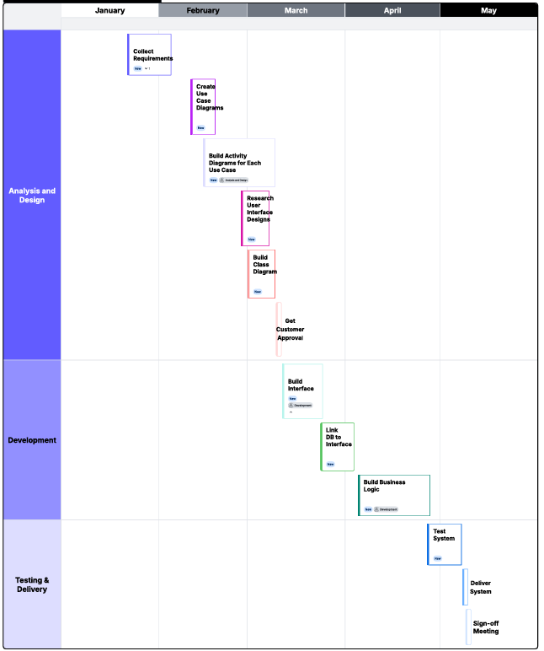
Please include a screenshot of the GANTT chart that you created with Lucidchart. Be sure to check that it meets the plan described by the characters in the interview.

